1 Before powering on the Pi, connect the Sense HAT to the Pi. Start the Pi and once booted, open Python3*.*

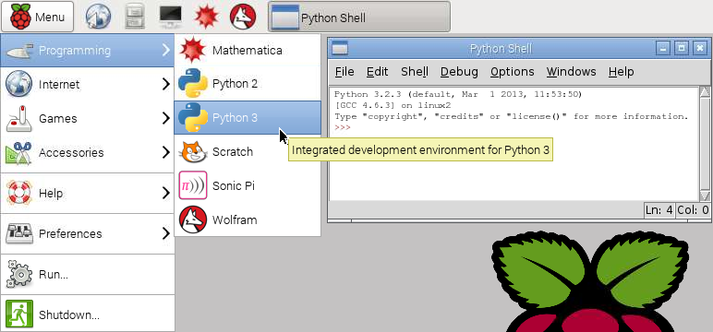

2 From the python shell open a new window (File > New Window). Start by saving this new file to the home directory as smiley.py. Then start by entering the following lines of code. These import the Sense HAT software and create a sense object. The third line makes sure the display is clear to begin with.

|  |
| --- |
| from sense_hat import SenseHat  sense = SenseHat()  sense.clear() |

3 The pixels (the LEDs) are arranged in a coordinate system. Numbering begins at the top left corner and counts from 0 (not 1). The blue pixel is at coordinates (0, 2), the red pixel is at coordinates (7, 4).

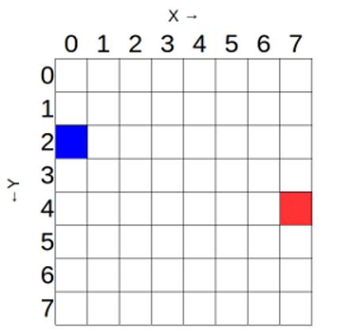

2 Add the following code to turn on two blue pixels and eight red pixels. The colours are set using RGB (Red Green Blue) values.

|  |
| --- |
| sense.set_pixel(2, 1, [0, 0, 255])  sense.set_pixel(5, 1, [0, 0, 255])  sense.set_pixel(3, 3, [255, 0, 0])  sense.set_pixel(4, 3, [255, 0, 0])  sense.set_pixel(1, 6, [255, 0, 0])  sense.set_pixel(2, 5, [255, 0, 0])  sense.set_pixel(3, 5, [255, 0, 0])  sense.set_pixel(4, 5, [255, 0, 0])  sense.set_pixel(5, 5, [255, 0, 0])  sense.set_pixel(6, 6, [255, 0, 0]) |

4 Back in the python shell window select Run > Run Module. The LED matrix pixels should show a grumpy face

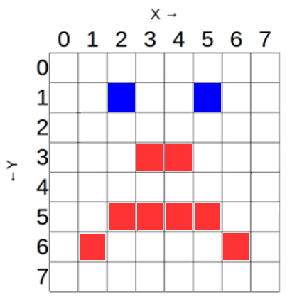

5 Try changing the program to display a smiley face instead of a grumpy face. Good luck!